Wesley L. Hiestand
May 18, 1873 – November 7, 1879
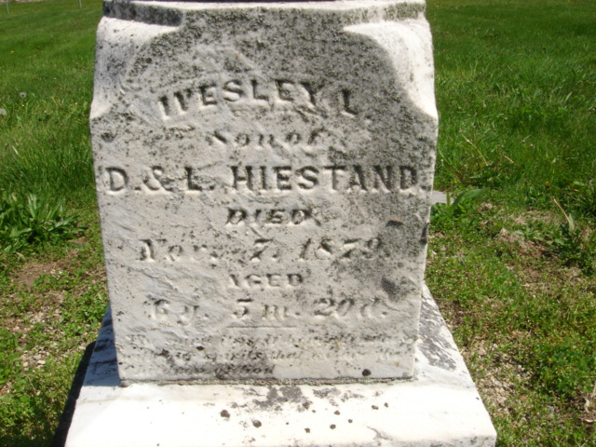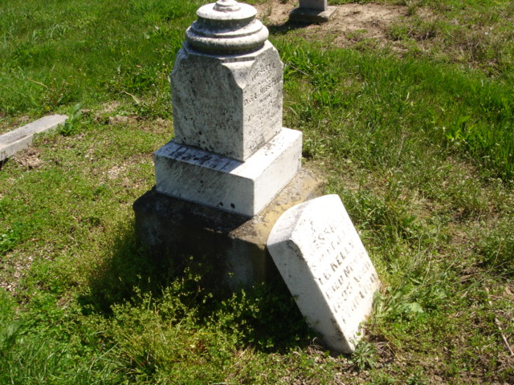
Photo by Cousin Becky

No obit found at this time

