Infant Son Hiestand
July 24, 1875 – July 24, 1875
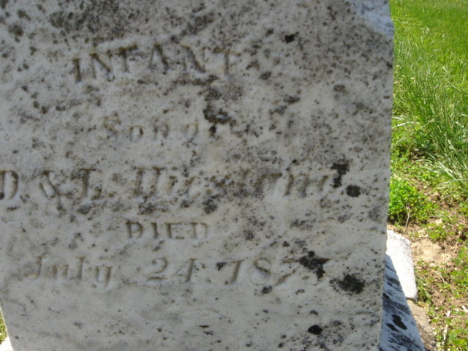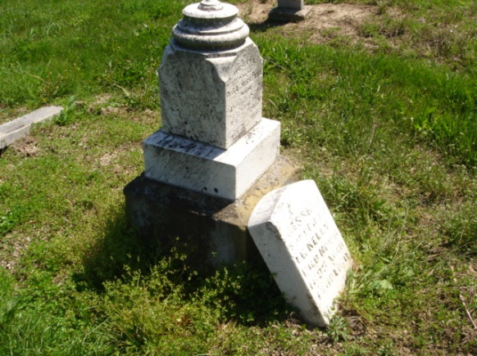
Photo by Cousin Becky

No obit found at this time

