Elizabeth W. Hammell
December 24, 1824 – April 13, 1855
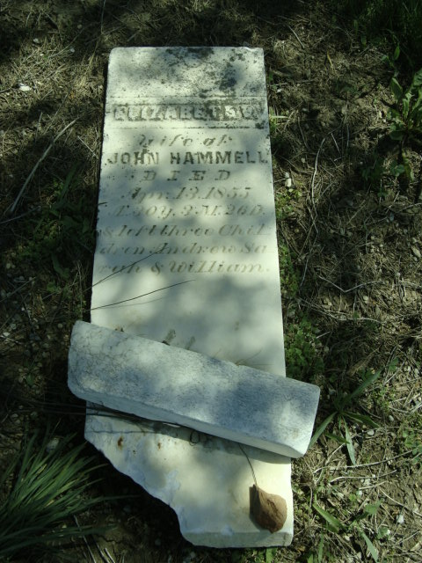
Photo by Cousin Becky

No obit found at this time

