Albert L. Ford
March 10, 1900 – December 11, 1901
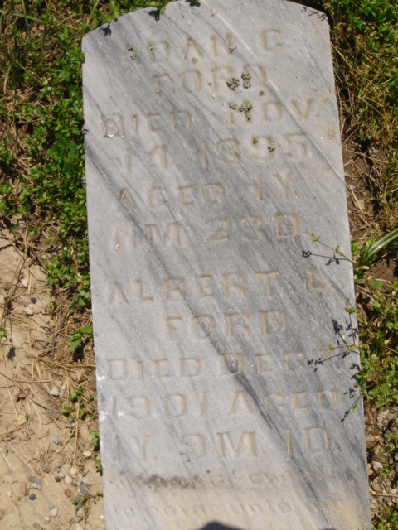
Photo by Cousin Becky
No obit found at this time

