Adam C. Ford
November 21, 1893 – November 14, 1895
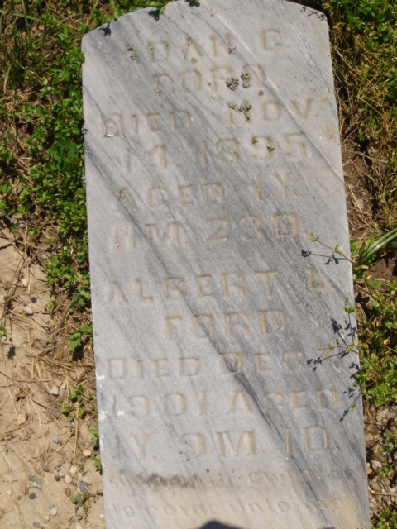
Photo by Cousin Becky
No obit found at this time

