Jacob Fogle
1820 – April 9, 1911
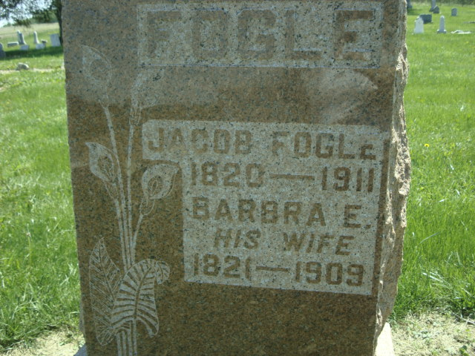
Photo by Cousin Becky

No obit found at this time

