Cordelia Jeanette Fetters
July 7, 1915 – March 30, 1919
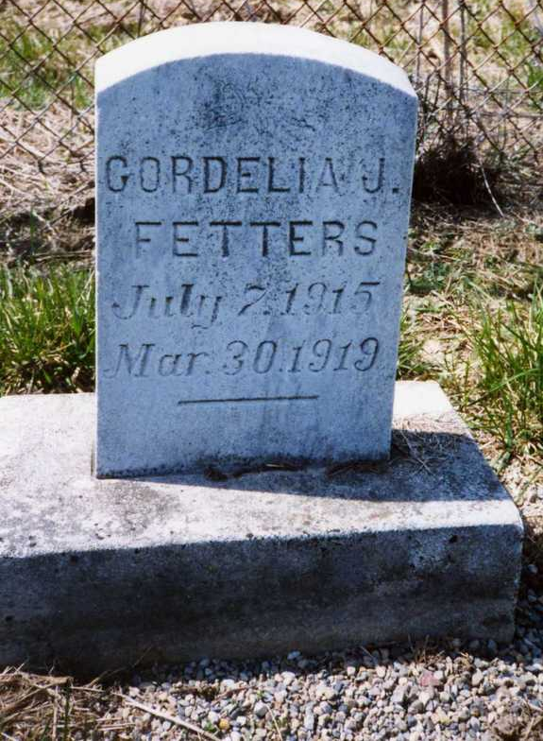
Photo by Dave Buckmaster

