Margaret I. (Shepherd) Belt
February 7, 1817 – September 7, 1848
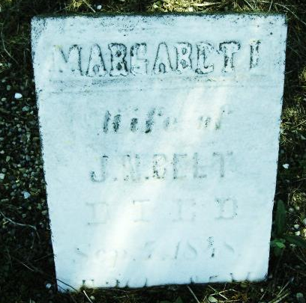
Photo by Cousin Becky

No obit found at this time

