Sarah C. (Wendell) Anspaugh
March 28, 1886 – July 20, 1918

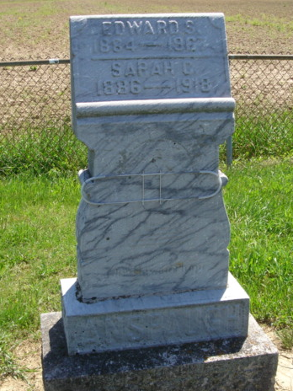
Photo by Cousin Becky

No obituary found at this time

