Steven W. Meshberger
June 21, 1948 – July 29, 2009

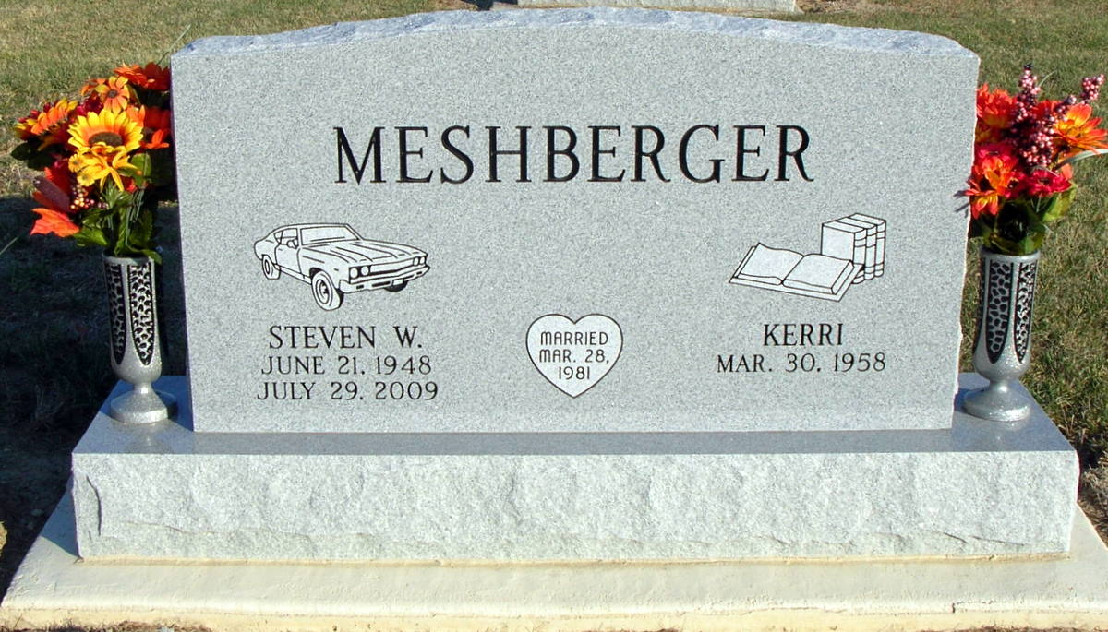
Photo by Jackie Sanders

Steven W. Meshberger, 61, a resident of Jacksonville, Florida and a former resident of Linn Grove, Indiana passed away in the morning hours of July, 29, 2009 in Jacksonville. Steven was born on June 21, 1948 in Adams County, Indiana the son of the late Robert Meshberger and Carolyn (Reynolds) Meshberger, a resident of Berne, Indiana. Steven is also survived by his wife, Kerri, a resident of Jacksonville, Florida.
Steven was a service technician in the banking industry. He had a special interest in restoring and showing antique cars. He was a member of the North Florida Chevelle Car Club and owned a 1971 Chevelle that he restored. His other interest included fishing and following the Blue Angels.
Steven is survived by his wife Kerri, a daughter, Millissent Meshberger of Jacksonville, Florida and a sister, Lisa (Karl) Steiner of Geneva, Indiana. Steven was preceded in death by his father, Robert Meshberger and a brother, Doug Meshberger.
Funeral services will be held at 10:00 a.m. Thursday, August 6, 2009 in the YagerKirchhofer Funeral Home in Berne, Indiana with the Rev. John Wolf officiating. Interment will be in the Greenwood Cemetery of Linn Grove, Indiana. Family and friends will be received from 5:00 – 8:00 p.m. Wednesday, August 5, 2009 in the Yager-Kirchhofer Funeral Home and one hour prior to the service at YagerKirchhofer on Thursday.
Preferred memorials are to the Adams County Community Foundation – Diabetes Fund.

Yager-Kirchhofer Funeral Home, Adams County, IN
August 17, 2014

