Omo Meshberger
August 21, 1893 – December 18, 1964

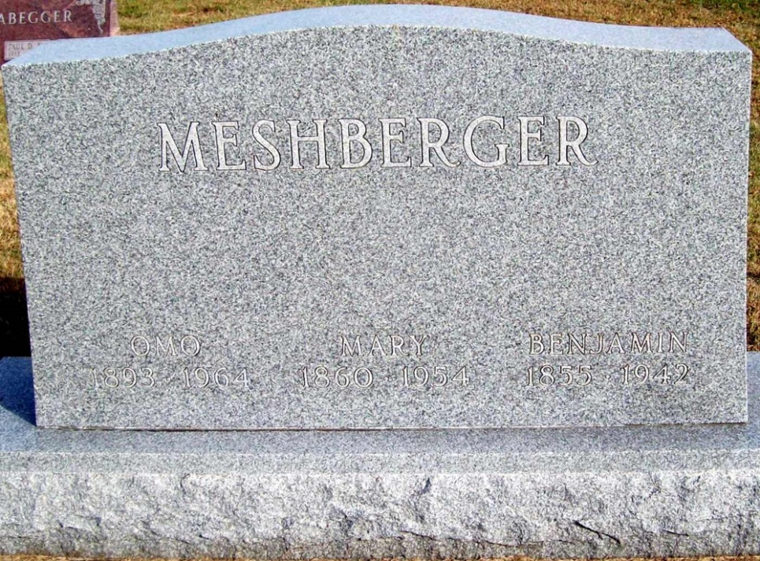
Photo by Jackie Sanders

Indiana, Death Certificates, 1899-2011

Name: Omo Meshberger
Gender: Female
Race: White
Age: 71
Marital status: Never Married (Single)
Birth Date: 21 Aug 1893
Birth Place: Indiana
Death Date: 18 Dec 1964
Death Place: Bluffton, Wayne, Indiana, USA
Father: Benjamin Meshberger
Mother: Mary Meshberger
Informant: Otis Buckey, administrator, Wells County Hosp
Burial: 12/21/1964, Green Lawn near Linn Grove, IN

