David Meshberger
January 4, 1851 – August 25, 1910

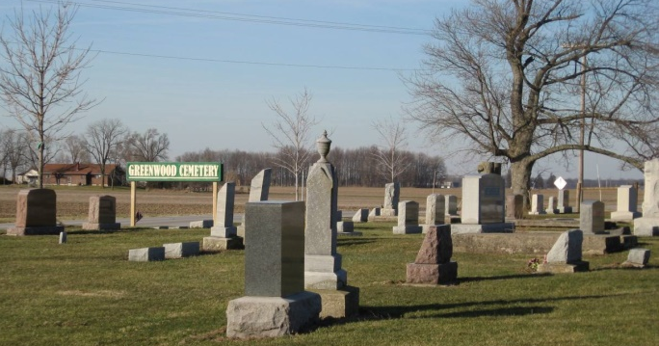
Photo by Scott Shoup

David Meshberger was born in Adams Co., Ind., Jan. 4, 1851 and died suddenly in Linn Grove Aug. 25, 1910, aged 59 years, 7 months, and 21 days. He was married to Jane Heller June 27, 1877. To this union were born 11 children, 4 sons and 7 daughters. Two daughters and one son preceded him to the spirit world. He leaves to mourn his departure, his sorrowing and heart broken wife, also the following children: Mrs. Cora Sales, Mrs. Lillie Banten, Mrs. Amelia Beeler, Rufus, Mrs. Kathrine Mosure, Harry, Effie, Oscar, and five grandchildren; six brothers, John, Benjamin, Abraham, Samuel, Fred and Jacob; three sisters, Mary Dunbar, Mattie Roan and Sarah Gerber.
Mr. Meshberger was well known and the attendance at his funeral was the largest of any held in Linn Grove. It was estimated that fully 1500 people were present. The services were conducted by his pastor, John Rees, assisted by Revs., C. P. Maas, of Berne, and J. J. Wise, of Ft. Wayne, Ind.

Berne Witness, Adams County, Indiana
Tuesday, Sept. 20, 1910
Contributed by Karin King
*****

DAVID MESHBERGER.
Men of sagacity and business ability are the rule rather than the exception among the descendants of the pioneers of northeastern Indiana. Many fine types may be found in Adams and adjoining counties, but none among the number apparently has achieved greater success or is more highly esteemed by his fellows than David Meshberger. He is the son of Jacob and Rosie (Rieffe) Meshberger, both natives of Berne, Switzerland, where the father was born in 1823. Jacob Meshberger emigrated to America when seventeen years of age and settled in Ohio, where he lived for a few years and then came to Adams county, Indiana.
The son, David, was born in French township, Adams county, in 1852. He spent his youth on his father's farm and attended the schools of his home township and developed into a successful and intelligent farmer. In 1877 he married Jane Heller, a daughter of George and Eliza (Gentis) Heller, who came to Indiana from Clark county, Ohio. The Heller and Gentis families were among the first settlers to brave the wilderness of Indiana. Members of these families came into the Indiana territory at a very early date when the Indians and wild beasts vied with them for the possession of the soil, and when the life of a pioneer family was continually fraught with dangers from both sources. Levi Heller, the paternal grandfather of the present Mrs. Meshberger, came to Indiana and settled in Wells county. Her grandparents on her mother's side, John Gentis, also came among the first to Indiana and lived until he was ninety-seven years of age, his death occurring only recently.
After his marriage to Miss Heller, David Meshberger bought a farm of forty acres in Adams county, half of which was cleared. He erected a three-room frame dwelling and mad a home for himself and his bride. He devoted himself to the task of clearing his timbered acres, and in time had the whole estate under profitable cultivation. He followed general farming and is crops each year were successfully marketed at a profit. As demand arose he increased the capacity of his farm building and in 1889 purchased an additional tract of eighty-five acres of land west of the river adjoining the village of Linn Grove. He has made his home on this tract since its purchase and has erected a fine home and commodious bars and outbuildings. From time to time he increased his farm holdings until today he is in possession of something like four hundred acres of the best and most highly improved land to be found anywhere in Adams county.
In addition to his land and farming enterprises, Mr. Meshberger owns and conducts a large stone business. He owns and operates a stone quarry which has been in his possession since he was about twenty-two years of age. The demand for his stone for building and road purposes is constant and ever-increasing, and he practically furnishes all the stone used in his part of the state for many miles' radius.
Eleven children have been born to Mr. and Mrs. Meshberger, of whom eight are living. Those who are living are: Cora, Lillie, Amelia, Rufus, Catherine, Harry, Effie and Oscar. Lena and Emma died in infancy and Noah later in his life. The Meshberger family is one of the most popular in Adams county. The home is noted for its hospitality and the social life of the district centers about it. Mr. Meshberger is an active and substantial man and a leader in his community. He is a Democrat.

Snow's History of Adams County, Indiana, John Fletcher Snow, B. F. Bowen, Indianapolis, IN, 1907, p. 441 (image 901).

