Rosa E. (Murphy) Liby-Bollinger
February 3, 1870 – June 9, 1939

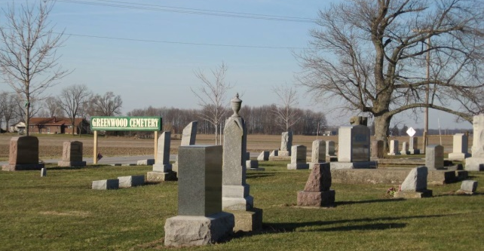
Photo by Tombstoner & Family

HEART ATTACK CLAIMS WOMAN
Mrs. Clement Bollinger Aged 68 Dies at Linn Grove Today

Mrs. Clement Liby Bollinger, aged 68, died of a heart attack at her home in Linn Grove this morning at 9:45 o'clock. She had been ailing for several years but was able to be up and around until the last few days.
The decedent was born in the Craigville community February 2, 1871, and her parents, Murphy [sic], died when she was three years old. She was reared by Mr. and Mrs. Ben Fisher.
She was a member of the Linn Grove Christian church where the final rites will be held Monday at 2 p.m. Her first marriage was to Wallace Liby who preceded 17 years ago. Her second marriage was to Clement Bollinger seven years ago last October. He survives.
Children surviving are Mrs. Jennie Sours, Linn Grove; Mrs. Rena French, Rockford, Ohio; Charles of Craigville; Alexander of Hamilton, Kansas; Mrs. Mae Shanks of Linn Grove; Raymond of Sturgis, Mich; Fred and William of Linn Grove and Gerald of Decatur. A twin of Gerald died in infancy. One sister, Mrs. Alice Noll, of Hillsdale, Mich. survives. One brother preceded many years ago.

Adams County, Indiana Historical Society 1939 Scrapbook
Handwritten date: Friday, June 9, 1939
Transcribed by Karin King

