Freddie A. Kreps
April 23, 1895 – January 11, 1900

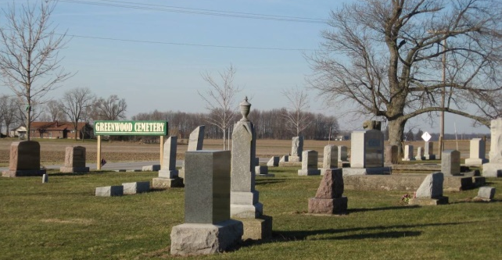
Photo by Tombstoner & Family

Again has the silver cord of life been severed, and one of its beautiful links torn away. A young life of usefulness and activity, that for a few years made glad the hearts of those in the home circle, has been called. This beautiful bud of promise, Freddie A. Kreps, was born into this life at Linn Grove, Ind., April 23, 1895, and was a source of joy and pleasure to the home circle for 13 years, 8 months and 18 days, He died on Monday, January 11, 1900, at 11:59 p.m. He leaves a grief stricken father, a loving mother and sister, Lillie, besides many relatives and friends who hold him in high esteem. His disease, which he had to battle with so heroically for over 21 days, and to which he finally succumbed, was typhoid fever in connection with an aliment of the brain and spine. During his sickness, Freddie was resigned to the will of his heavenly Father, in whom he had confidence. He seemed to have a premonition that he would not recover from his bed of affliction. He spoke about his death as though he were going to sleep. The memory of Freddie and the loving words he spoke to all, most especially to his home circle, will never be effaced. He gave his heart to God during a revival, two years ago under the labors of Rev. E. Greiner, and was a regular attendant at Sabbath school and church. Deceased was laid to rest at Greenwood Cemetery to await the call of the last trumpet. May the Lord bless and comfort the bereaved and grief stricken parents and sister as well as relatives and friends and grant to them all a happy reunion in the home of many mansions. Rev. J.L. Buyer, of Linn Grove, officiated. Burial on Friday morning at 9:30 a.m. from the Evangelical church.

Contributed by Sandy – no source listed

