Norma Jean Idlewine
September 2, 1933 – February 8, 1938

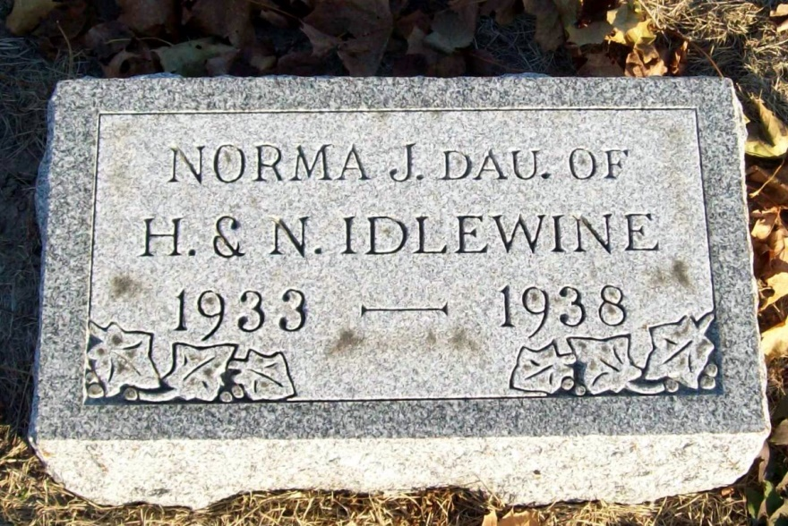
Photo by Jackie Sanders

YOUNG GIRL IS TAKEN BY DEATH
Norma Jean Idlewine Dies Tuesday Afternoon of Influenza

Norma Jean Idlewine, four, daughter of Mr. and Mrs. Harold and Nellie Bixler-Idlewine, of 604 N. 2nd St., died at 2:45 o'clock Tuesday afternoon. Death was caused by complications following influenza. Surviving are the parents and three grandparents, Mr. and Mrs. John Bixler and Charles Idlewine. A brother preceded her in death July 5, 1936. Funeral services will be held at the home Friday at 1:30 o'clock and at the Evangelical church, of which she was a member, at 2 o'clock. Rev. George S. Lozier, pastor of the church, will officiate. Burial will be made in the Greenwood Cemetery at Linn Grove.

Decatur Daily Democrat, Adams County, Indiana
Wednesday, Feb. 9, 1938
*****

Handwritten-Thurs. Feb. 10, 1938

4-YEAR-OLD GIRL IS DEAD
Norma Idlewine Dies After Short Illness; Funeral Friday

Norma Jean Idlewine, four-year-old daughter of Mr. and Mrs. Harold Idlewine, of Decatur, formerly of Geneva, died at 2:45 o’clock Tuesday afternoon at the Idlewine residence, 604 N. Second street.
Death was caused by complications following influenza.
The girl was born at Geneva, and was a daughter of Harold and Nellie Bixler Idlewine.
Surviving are the parents and three grandparents, Mr. and Mrs. John Bixler, of southwest of Berne, and Charles Idlewine. A brother preceded her in death July 5, 1936.
The funeral will be held Friday afternoon at 1:30 o’clock at the home at Decatur, and at 2 o’clock at the Evangelical church, Rev. George S. Lozier officiating. Burial will be in Greenwood cemetery near Linn Grove.
The child has several close relatives in Berne.

Adams County Historical Museum
1938Mar-Jan1939 Scrapbook, image 064-065

*****
Indiana, Birth Certificates, 1907-1940

Name: Norma Jean Idlewine
Gender: Female
Birth Date: 2 Sep 1933
Birth Place: Wabash, Adams, Indiana, USA
Registration Year: 1933
Father: Harold Idlewine
Mother: Nellie Bixler
Certificate Number: 34217; Roll Number: 014
Agency: Indiana State Board of Health; Volume Range: 66 - 70

