Isabelle (Raymond) Grandlienard
August 29, 1918 – November 17, 1997

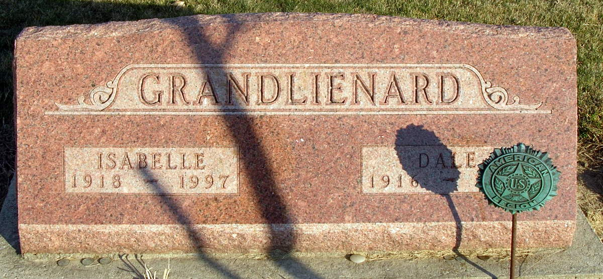
Photo by Jackie Sanders

ISABELLE GRANDLIENARD, 79, died Monday at Caylor-Nickel Medical Center, Bluffton. Born in Fort Wayne, she was an Avon sales representative for more than 35 years. Surviving are her husband, Dale; a son, Steve Randolph of Cut and Shoot, Texas; two daughters, Judy Neuenschwander and Melissa Fey, both of Berne; and two grandchildren. Services at 10:30 a.m. Wednesday at Goodwin Memorial Chapel, Bluffton, with calling from 2 to 9 p.m. today. Burial in Greenwood Cemetery. Memorials to American Heart Association.

Journal Gazette, The (Allen County, IN)
Tuesday, November 18, 1997
Contributed by Jane Edson

