Lillian Elizabeth (Kreps) Fosnaugh
August 11, 1893 – January 1, 1944

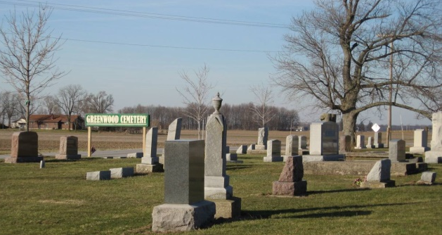
Photo by Tombstoner & Family

Mrs. Lillie Fosnaugh Dies This Morning
Funeral Services Tuesday Afternoon

Mrs. Lillie Fosnaugh, 50, wife of George Fosnaugh, well-known Washington Township farmer, died early this morning at the Adams County Memorial Hospital after an extended illness of nephritis. She had been ill for the past 10 years.
Mrs. Fosnaugh was born in Hartford Township, August 8, 1893, a daughter of Rufus and Minnie Schapp-Kreps. She was married May 5, 1915 and lived her entire life in this county.
Besides her husband, she is survived by her father, who lives at Bluffton, three sons, Arthur of near Monroe; Frederick of Linn Grove and Tech. Cpl. James Fosnaugh of Camp Atterbury, Ind.; and three daughters, Mrs. Weldon Stucky of Monroe; Betty and Norma, at home. One brother is deceased. Three grandchildren also survive.
Her death was the first to be recorded in this city in the New Year.
Funeral services will be held Tuesday afternoon at 1 o’clock from the home, four miles southeast of Decatur on the county farm road and at 2 o’clock from the Evangelical Church in Linn Grove, of which she was a member, with Rev. Oscar Fleshes officiating. Burial will be in the Linn Grove Cemetery. The body will be moved from the Zwick Funeral Home to the Fosnaugh farm home Sunday afternoon, where it may be viewed.

Adams Co Historical Museum 1943A Scrapbook
Saturday, January 1, 1944
Transcribed by Jim Cox
*****
Indiana, Death Certificates, 1899-2011

Name: Mrs Lillie E Fosnaugh [Mrs Lillie E Kreps]
Gender: Female; Race: White; Age: 50; Marital status: Married
Birth Date: 11 Aug 1893; Birth Place: Hartford Twp, Adams Co, IN
Death Date: 1 Jan 1944; Death Place: Decatur, Adams, Indiana, USA
Father: Rufus Kreps; Mother: Minnie Schapp
Spouse: Geo. Fosnaugh, informant
Burial: 1/4/1944, Linn Grove Cemetery

