Joseph Eckrote
February 17, 1812 – May 6, 1900

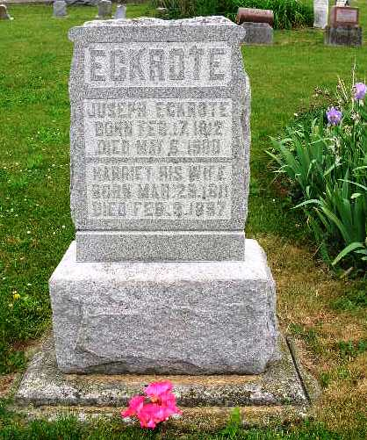
Photo by Jackie Sanders

Indiana, Death Certificates, 1899-2011

Name: Joseph Eckroat
Gender: Male
Race: White
Age: 88y, 2m, 19d
Marital status: Widow
Birth Date: abt 1812
Birth Place: Pennsylvania
Death Date: 6 May 1900
Death Place: Geneva, Adams, Indiana, USA
Father: Christal Eckroad
Mother: unknown
Informant: Joseph A Eckroat
Burial: May 9, 1900; Greenwood

