Ivan A. Duff
June 14, 1924 – July 13, 2000

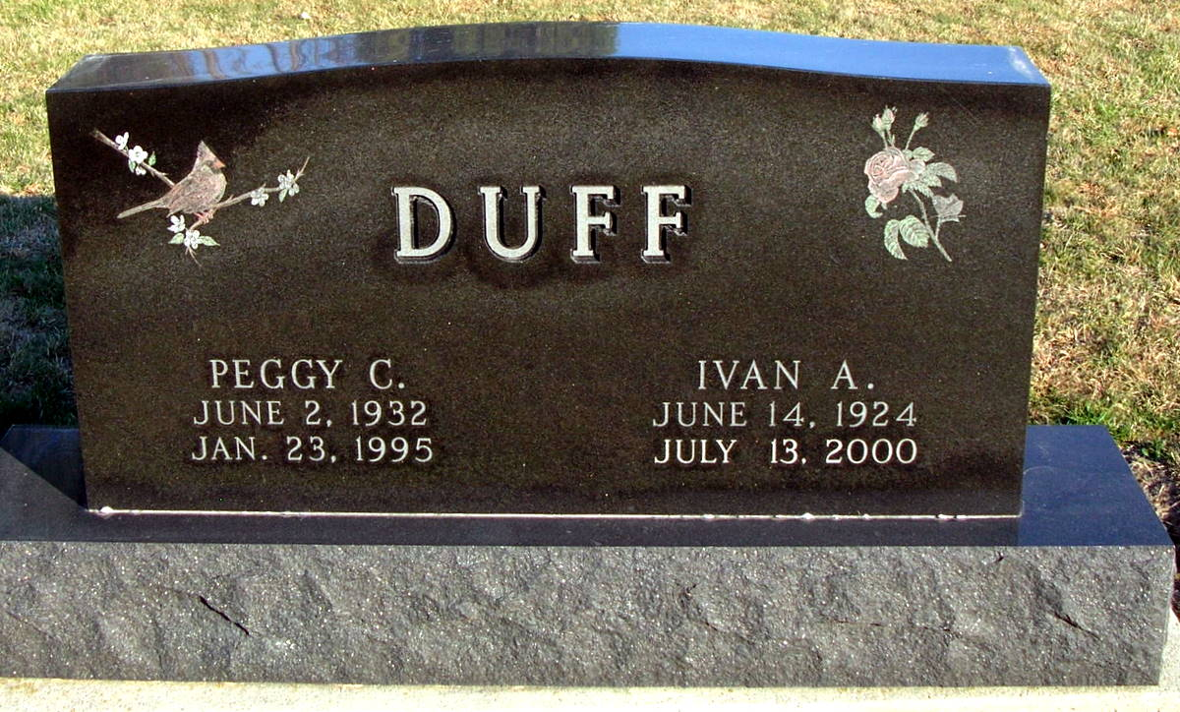
Photo by Jackie Sanders

Ivan A. Duff Geneva - 1924-2000

Ivan A. Duff, 76, of Geneva, an area farmer, died Thursday, July 13, 2000, at Adams County Memorial Hospital. The Adams County native was retired. He had worked for General Electric Co. in Decatur, Fruehuaf Trucking Co. in Fort Wayne, for D.J. Equipment in Berne and attended Faith Baptist Church in Portland. Surviving are his wife, Charlene; a son, Toby of Linn Grove; a daughter, Candace Waters of Portland; stepdaughters Yvonne Duff of Linn Grove and Andrea Colpaert of Berne; a brother, Fredrick of Monroe; two grandchildren; and one stepgrandchild. He was preceded in death by his first wife, Juanita, his second wife, Peggy, and a sister, Etta J. Duff. Services are 10:30 a.m. Saturday at Faith Baptist Church, Portland, with calling one hour before services. Calling is also from 2 to 8 p.m. today at Yager-Kirchhofer Funeral Home, Berne. Burial will be at Greenwood Cemetery, Linn Grove. Memorials are to the church TV Ministry or Gideons International. Information provided by Yager-Kirchhofer Funeral Home, Berne, 1-219-589-3101.

News-Sentinel, The (Allen County, IN)
Friday, July 14, 2000
Contributed by Jane Edson

