Frederick J. Duff
November 16, 1913 – November 5, 2002

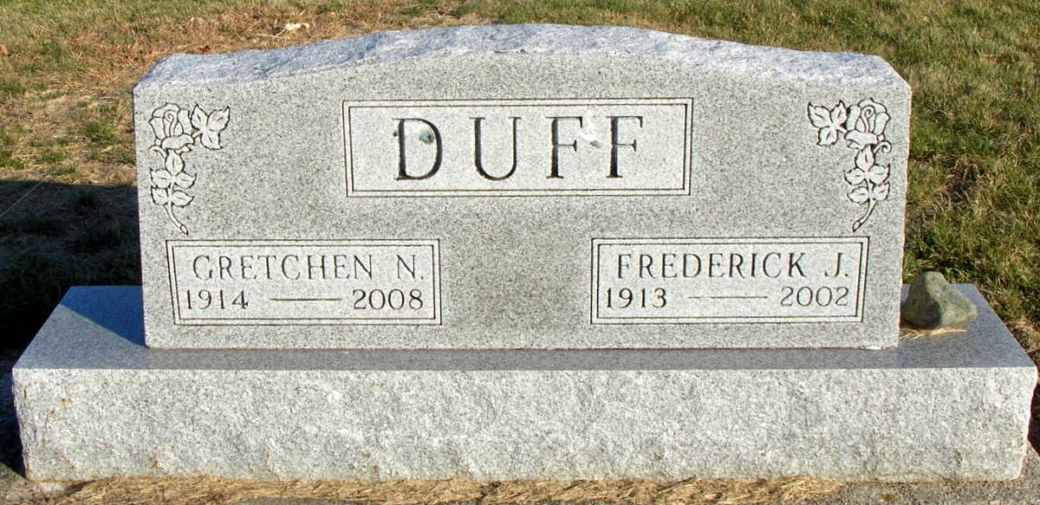
Photo by Jackie Sanders

MONROE - Frederick J. Duff, 88, died Tuesday in Adams County Memorial Hospital. The Adams County native was a lifelong Hartford Township farmer. Survivors include his wife, Gretchen, children, Jane Sickman, Fairmount, Mary Ann Lindsey, Bryant, and Larry, California grandchildren, Linda Sickman, Fort Wayne, and Janet Shindler, Fairmount and great-grandchildren, Jared and Josiah Shindler, both of Fairmount. Services: 2 p.m. Friday in Zwick & Jahn Funeral Home, Decatur. Burial is in Greenwood Cemetery, Linn Grove. Visitation is 2-4 and 6-8 p.m. Thursday at the funeral home. Memorials may be made to Linn Grove United Methodist Church and the Juvenile Diabetes Research Foundation.

Chronicle-Tribune (Marion, IN)
Wednesday, November 6, 2002
Contributed by Jane Edson

