Adelma H. Coover
September 17, 1903 – November 18, 1976

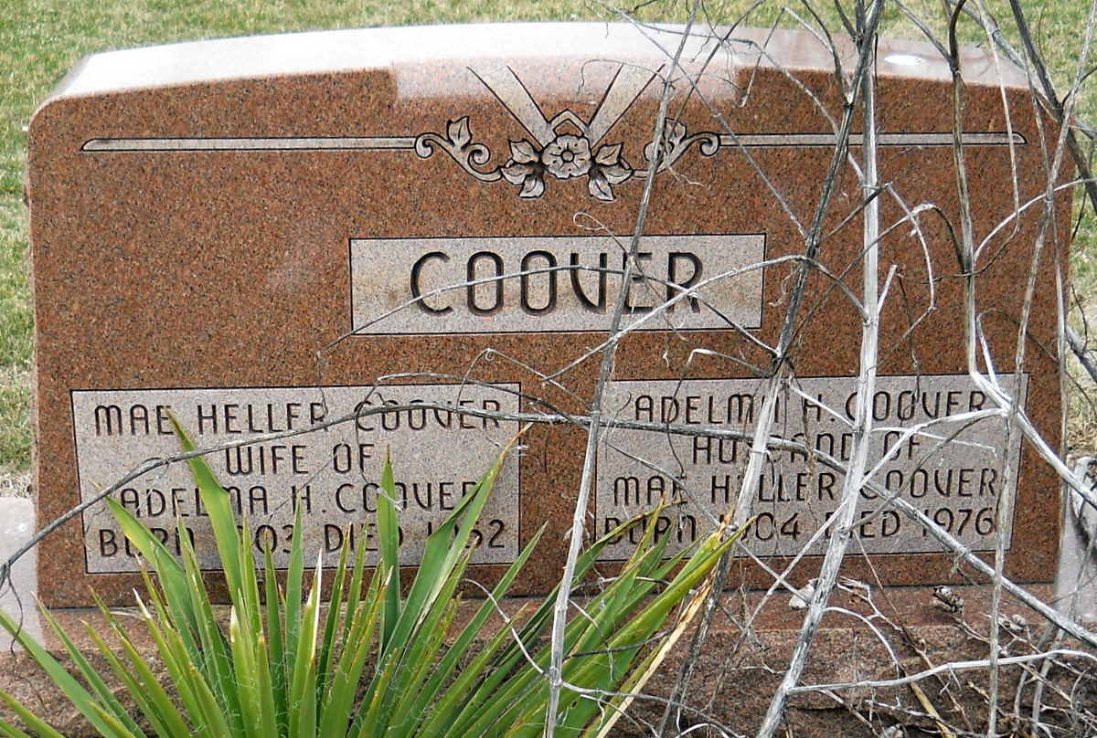
Photo by Jackie Sanders

Indiana, Death Certificates, 1899-2011

Name: Adelma H. Coover
Gender: Male
Race: White
Age: 73
Marital status: Divorced
Birth Date: 17 Sep 1903
Birth Place: Indiana
Death Date: 18 Nov 1976
Death Place: Allen, Allen, Indiana, USA
Father: John Coover
Mother: unknown
Informant: Miss Carol Coover, daughter
Burial: Nov. 20, 1976; Greenwood Cemetery

