Dale E. Bixler
April 28, 1912 – December 5, 1999

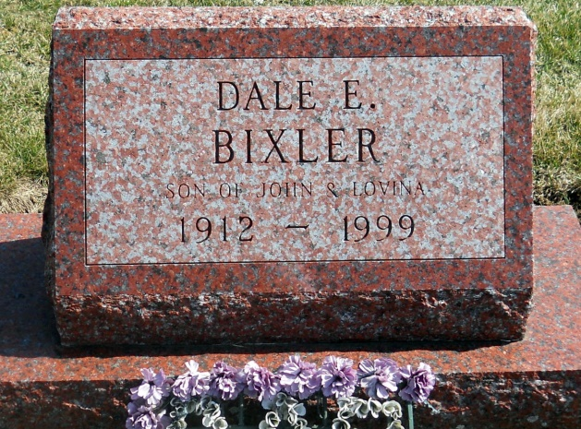
Photo by Jackie Sanders
Dale E. Bixler Berne - 1912-1999
Dale E. Bixler, 87, of Berne, a retired truck driver for the ABC Bus Line, International Harvester, died Sunday, Dec. 5, 1999, at Adams County Memorial Hospital. The Linn Grove native was a security guard for American Security Investment Co. Surviving are a daughter, Kay of Jackson, Mich.: a stepson, Glen Mullins of Fort Wayne; sisters Orpha Spahr, Marjorie Zimmerman and Nellie Idlewinc, all of Berne; brothers Roy and Virgil, both of Decatur, and Glen of Berne. He was preceded in death by a brother, and two sisters. Services are 10:30 a.m. Wednesday at Yager-Kirchhofer Funeral Home, Berne, with calling from 3 to 8 p.m. Tuesday and from 9 a.m. until services Wednesday at the funeral home. Burial will be in Greenwood Cemetery, Linn Grove. Memorials are to Adams County Hospice. Information provided by Yager-Kirchhofer Funeral Home, Berne, 1-219-589-3101.
News-Sentinel, The (Allen County, IN)
Monday, December 6, 1999
Contributed by Jane Edson

