Andrew Ralstian
November 13, 1880 – September 18, 1881

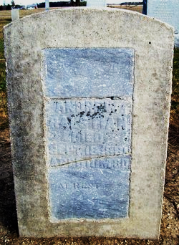
Photo by Jackie Sanders

Andrew Ralston from tree Conrad Family Tree #3
Birth 1880 Wells, Indiana, USA
Death 1881 Wells, Indiana, USA
Father William Ralstain (1844-1914)
Mother Frances Fields (1855-1913)

