William Elroy Pine
May 12, 1873 – November 5, 1885

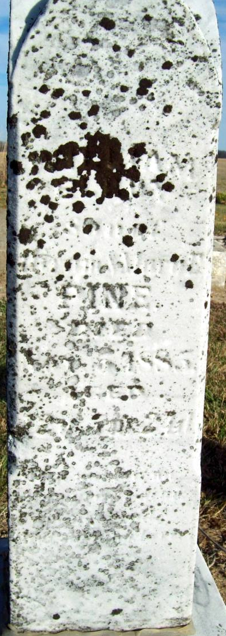
Photo by Jackie Sanders
William Elroy Pine from tree Robson Family Tree
Birth 12 May 1873 Adams, Indiana, USA
Residence 1880 Adams, Indiana, USA
Death 5 Nov 1885 Adams, Indiana, USA
Father Hiram Pine (1841-1911)
Mother Mary Thelma Eckroat (1846-1914)

