Martha (Sales) Pine
September 30, 1816 – June 11, 1886

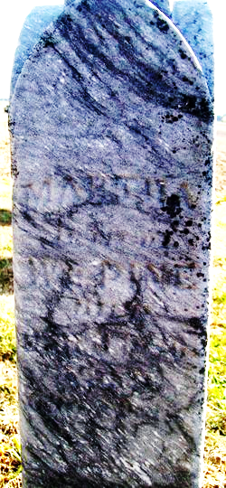
Photo by Jackie Sanders

Martha Sales Pine from tree Kristi Gardner Family Tree
Birth 30 Sep 1816 Huntingdon, Huntingdon, Pennsylvania, USA
Marriage 25 Oct 1838 Ohio, USA
Residence 1880 Adams, Indiana, USA
Death June 11, 1886 OR 2 Apr 1896 Linn Grove, Adams, Indiana, USA
Father John Sales (1754-1838)
Mother CATHARINE LNU (1770-1837)
Spouse William Pine (1820-1862)

