Infant Pine
September 25, 1877 – September 25, 1877

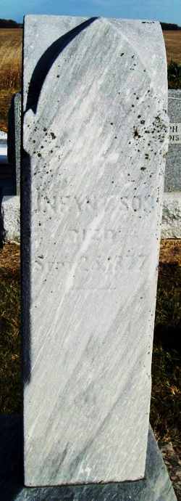
Photo by Jackie Sanders

No further information found at this time

