Infant Son Pine
August 2, 1875 – February 4, 1876

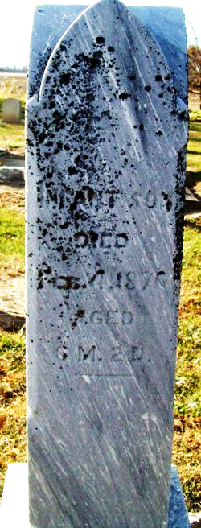
Photo by Jackie Sanders

No further information found at this time

