Hiram Pine
May 10, 1841 – June 9, 1911

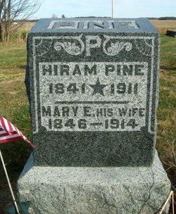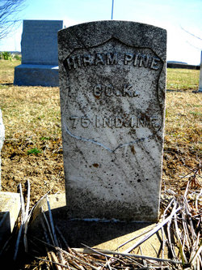
Photo by Jackie Sanders

Hiram Pine, a resident of Geneva, Ind., died last evening at 7 o'clock at the St. Joseph's Hospital. Death followed an operation for bladder trouble. The deceased was about 55 years old.
The body was removed to the N. W. Bloom Undertaking Parlors, and will be shipped to Geneva, Ind., where burial will take place.

Journal‐Gazette, Allen County, Indiana
June 10, 1911

**
Indiana, U.S., Death Certificates, 1899-2017
Name Hiram Pine
Gender Male
Race White
Marital Status Married
Age 68
Birth Date 10 May 1833 [sic]
Birth Place Ohio
Death Date 9 June 1911
Death Place Fort Wayne, Allen, Indiana, USA
Death Registration Date 1911
Father Wm Pine
Mother Martha Sales
Spouse Mary Ellen
Informant Joseph Eckrote; Geneva, Indiana
Burial June 10, 1911; Geneva, Indiana

