Solomon Mosser
March 21, 1843 – January 16, 1899

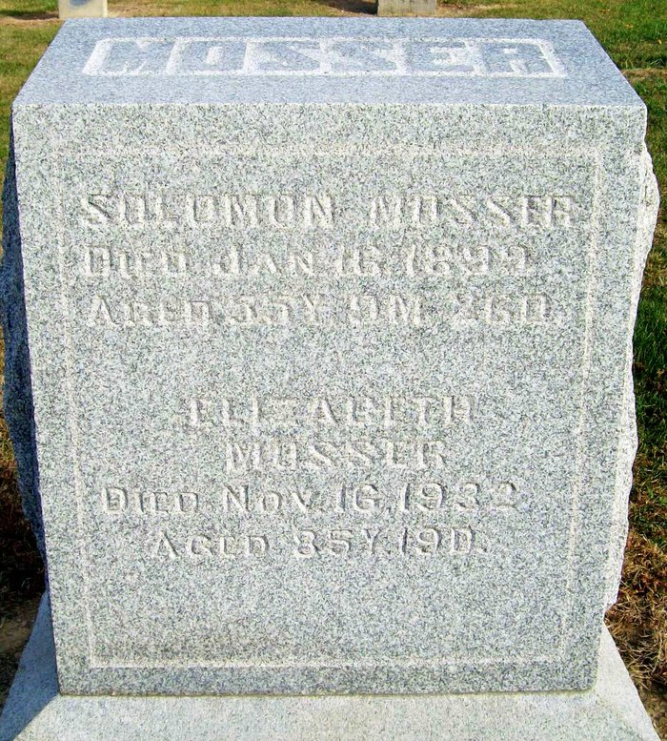
Photo by Jackie Sanders

Soloman Moser [sic], one of the county's best-known citizens, died at his home in the south part of Hartford Township, after an illness that had continued, more or less, for twenty years. He was afflicted with liver and kidney complaint, which was incurable, except for a short time. At intervals he had suffered terribly, and he felt as though his life was slowly wearing away. Last fall he came to this city and had his will drawn, and a short time afterwards he was advised by his physicians to make a hunting trip to Minnesota, which he did, remaining several weeks. The trip did him no good and since his return some eight weeks ago, he has grown steadily weaker until noon Monday when he died.
He was born in Wayne County, Ohio, in 1843, when a small child, however, his parents removed with him to this county and settled on a farm about three miles south of Buena Vista, where Solomon was destined to spend his life. He grew to manhood on the old home farm, as it was called, and then took charge of the farm himself and has lived there ever since. He was honest, hardworking man and by his industry, accumulated enough to make himself and family comfortable, notwithstanding his long illness.
He was married in 1862 to Elizabeth Schalter [sic] and to them have been born sixteen children, twelve of whom, with the devoted wife, remain to mourn their loss. The three oldest boys have been located at Van Buren for several years, while the rest of the family remain in this county. He was a brother-in-law of J. R. Graber, superintendent of the county farm, and has many friends and acquaintances in this city.
During the past few years Mr. Moser has been interested quite extensively in the oil business, and it is said he owned seventy-five shares in wells at the time of his death. He was a kind and loving father and husband, and the family will feel their loss most keenly.
Funeral services were held from the Union Chapel church near his home at nine o'clock Wednesday morning, conducted by Rev. Egley and the minister of the chapel.

Decatur Democrat; Adams County, Indiana
A weekly newspaper
Thursday, January 19, 1899
**
Adams Co, INGenWeb – Wills
Solomon Mosser
Name in Record Reason for Being in Record Date of Record
Solomon Mosser Of Adams County, Indiana; makes his last will & testament; April 22, 1898
Elizabeth Mosser, Wife; inherits real estate & $500.
Joseph Mosser, Son; to share remainder of estate
Catharine A. Mosser, Daughter; to share remainder of estate
Lydia Mosser, Daughter; to share remainder of estate
Elizabeth E. Mosser, Daughter; to share remainder of estate
Barbery R. Mosser, Daughter; to share remainder of estate
Christian C. Mosser, Son; to share remainder of estate
Noah Mosser, Son; to share remainder of estate
Levi Mosser, Son; to share remainder of estate
Meno Moser, Son; to share remainder of estate
Solomon Mosser, Son; to receive $200 less than the rest of the children
John Mosser, Son; to receive $400 less than the rest of the children
W. W. Briggs, Witnessed Solomon Mosser making his last will
Thomas Drew, Witnessed Solomon Mosser making his last will
Solomon Mosser Died Jan. 16, 1899
William W. Briggs, Subscribing witness; oath of death & validity of will; Jan. 26, 1899
John H. Lenhart, Clerk; will has been admitted to probate; Jan. 26, 1899
E. Burt Lenhart, Deputy

**
SOLOMON MOSSER, a prominent agriculturist of Hartford Township, was born in Wayne County, Ohio, March 20, 1843, a son of Abraham and Catherine (Eicher) Mosser, natives of France and Germany respectively, the father born in 1793, and the mother in 1800. The father was a weaver by trade. He traveled in different parts of Europe and was married in Germany. He came to America with his wife and two children, one child having died in Germany, and settled in Wayne County, Ohio, in 1827, where he engaged in farming. He removed his family to Adams County, Indiana, in 1854, and made his home on section 22, Hartford Township, till his death, which occurred March 25, 1876. The mother died in November 1870. Fourteen children were born to them, seven sons and seven daughters. The parents were members of the Mennonite church. The father had but $100 when he landed in America, and with this he bought eighty acres of timber land, which he improved and added to it, and sold it in 1853. He then bought land in Adams County to which he removed his family the following year, as before stated.
Solomon Mosser, the subject of this sketch, was but a lad when his parents came to Adams County, and here he grew to manhood on the old homestead, and in his youth received but limited educational advantages. On attaining his majority he began working the farm on shares for one year. March 9, 1865, he was married to Miss Elizabeth Schlatter, who was born in French Township, Adams County, October 28, 1846, a daughter of Joseph Schlatter, an old settler of French Township. He was born in Germany, coming to America with his parents when about twelve years old. After his marriage he came to Adams County, Indiana, and he settled in French Township, where he lived till his death. He and his wife in their religious faith were Mennonites. Their family consisted of five daughters.
To Mr. and Mrs. Mosser have been born fourteen children - Mary, David (deceased), Joseph, Catherine A., Lydia, Franna, Abraham (deceased), Solomon, John H., Elizabeth E., Barbara Rebecca, Christian C., Noah, and an infant unnamed. After his marriage Mr. Mosser bought the old homestead of his father on which he still resides, and cared for his parents till their death. He has improved his farm, making it one of the finest in the township, and in connection with his general farming he is extensively engaged in raising stock. He was the first man in his township to engage in raising thoroughbred stock, commencing this enterprise in 1877, and has now on his farm several head, some of which were brought from Kentucky. Mr. Mosser, like his parents, is a member of the Mennonite Church.

Biographical and Historical Record - Adams and Wells Co. Indiana Lewis Publishing Co. Chicago, IL 1887

