Sarah (Brown) Miller
June 5, 1846 – September 25, 1932

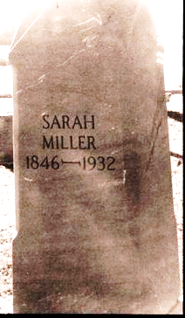
Photo by Melvin Witschi

Mrs. Sarah Miller (Brown) was born June 5, 1846 in Range Twp., Madison County, Ohio. On June 7, 1874 she was united in marriage to Peter D. Miller at the bride's home by Reverend Armstrong of Geneva Church. To this union were born seven children. The husband and two children have preceded her in death.
Early in life she united with the M.E. Church at Ceylon, later moving her membership to Geneva where she attended until her health
failed.
She was a kind mother and well liked by all who knew her. She departed this life September 25, 1932, making her age 86 years, 3 months, and 20 days.
Funeral services were conducted Wednesday afternoon from Geneva M.E. Church, W.B. Fallis officiating. Laid to rest in Brown Cemetery.

Unknown source

**
Indiana, U.S., Death Certificates, 1899-2017

Name Sarah Miller
[Sarah Brown]
Gender Female
Race White
Marital Status Widowed
Age 86 years, 3 months, 20 days
Birth Date 5 Jun 1832 [sic]
Birth Place Ohio
Death Date 25 Sep 1932
Death Place Geneva, Adams, Indiana, USA
Death Registration Date 1932
Father Bengiman Brown
Mother Marguet Johnson
Informant Mrs. Emma Miller; Geneva, Indiana
Burial September 27, 1932; Brown Cemetery

