Acha (Bellis) Michael
July 6, 1833 – April 15, 1901

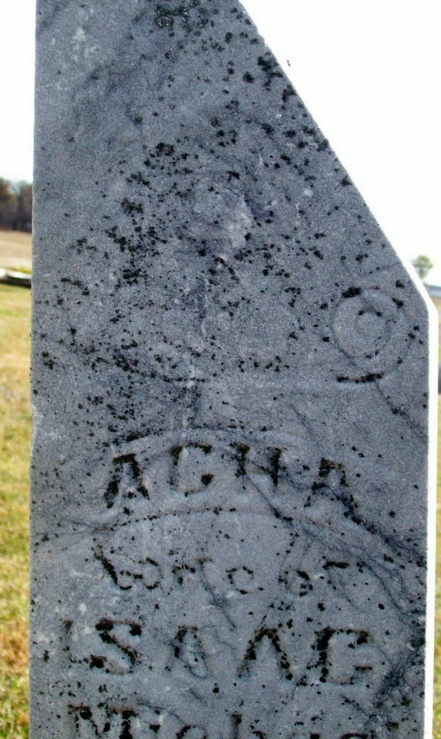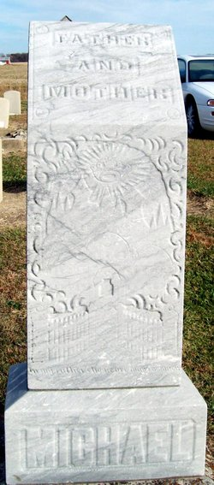
Photo by Jackie Sanders
Acha Michaels
in the Indiana, U.S., Death Certificates, 1899-2017
Name Acha Michaels
[Acha Bellis]
Gender Female
Race White
Marital Status Married
Age 68
Birth Date abt 1833
Birth Place Ohio
Death Date 15 Apr 1901
Death Place Hartford, Adams, Indiana, USA
Death Registration Date 1901
Father Adam Bellis
Mother Louisa Williamson
Informant Alexander Michaels; Geneva, Indiana
Burial April 16, 1901; Brown Cemetery
**
Acha Michael from tree Cindy's Family Tree
Birth 6 Jul 1833 Ohio, USA
Marriage 7 Aug 1853 Darke, Ohio, USA
Residence 1900 Adams, Indiana, USA
Death 15 Apr 1901 Adams, Indiana, USA
Father Adam Bellis (1790-1849)
Mother Lucretia Williamson (1792-1855)
Spouse Isaac Michael (1835-1911)

