Ligurgus Martin

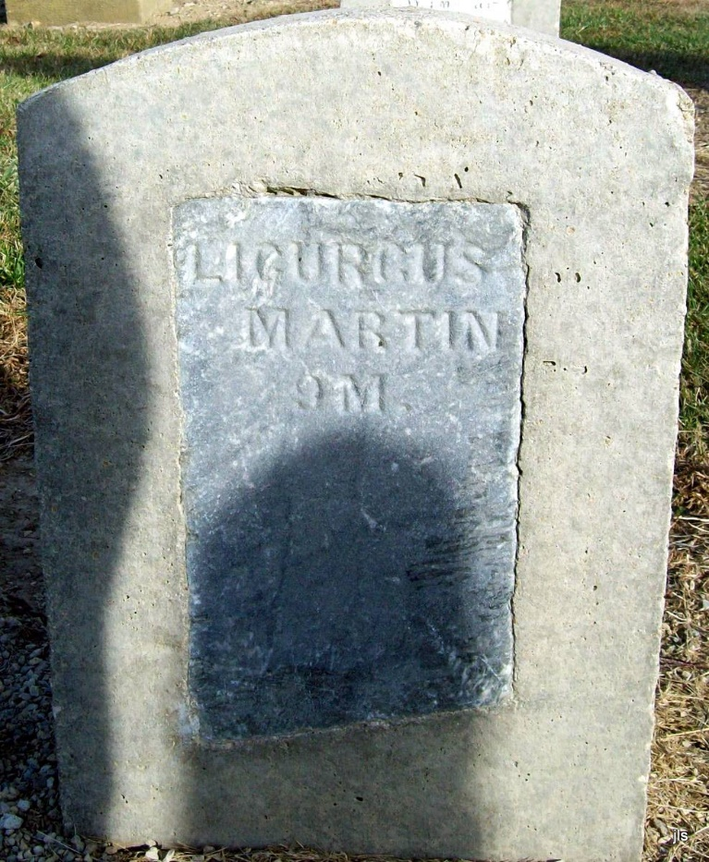
Photo by Jackie Sanders

No further information found at this time

