Josephus Luther Martin
September 30, 1803 – March 10, 1892

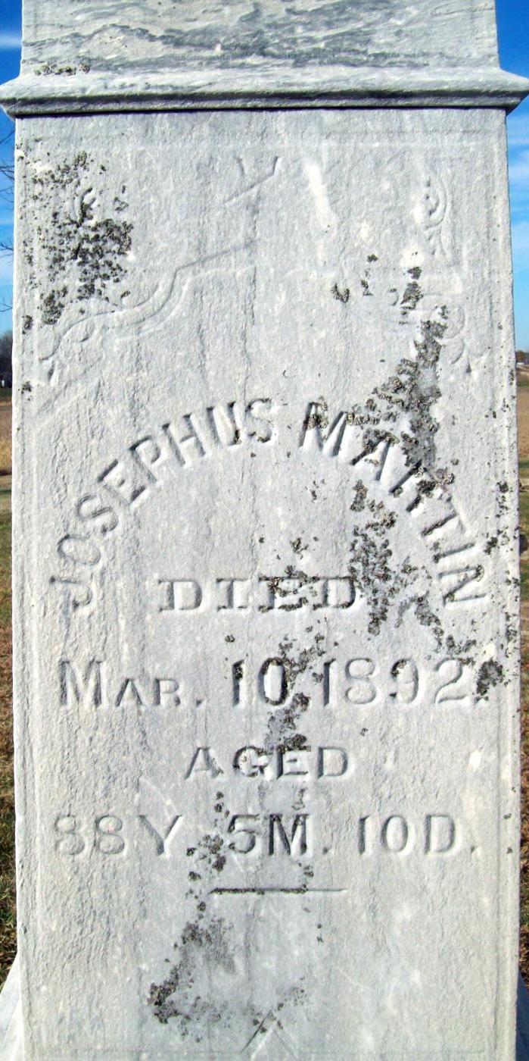
Photo by Jackie Sanders

JOSEPHUS LUTHER MARTIN from tree Kathleena D Waller Family Tree Research
Birth 30 Sep 1803 Virginia, USA
Marriage 27 Jan 1846 Allen, Indiana, USA
Residence 1880 Adams, Indiana, USA
Death 10 Mar 1892 Geneva, Adams, Indiana, USA
Father ROBERT ASHLEY MARTIN (1785-1868)
Mother SARAH B NORRIS (1783-1834)
Spouse Catherine "Kitty Ann" Summerfelt (Flummerfelt?) (1814-1844)
Spouse Elizabeth Cresap Deffenbaugh (Martin) (1828-1909)

**
JOSEPHUS MARTIN, farmer, section 24, Hartford Township is one of the old pioneers of Adams County, and was born in Hampshire County, Virginia, September 30, 1803. His parents were also natives of Virginia, his grandfather having settled there about the time of the Revolutionary war. They were of German origin. The family removed to Warren County, Ohio, where the parents died. Josephus went with his parents to Ohio, and remained at home until twenty-eight years of age, when he was married, March 25, 1830, to Catherine Summerfelt, born in New Jersey July 7, 1814. They had six children - Sarah, Rosetta, Ellen C., Morton J., Emma D. and Phebe C. Mrs. Martin died January 19, 1844, and January 27, 1845 Mr. Martin was married to Elizabeth Deffenbaugh, daughter of John Deffenbaugh, of this county. Mr. and Mrs. Martin are the parents of eleven children.

Biographical and Historical Record - Adams and Wells Co. Indiana Lewis Publishing Co. Chicago, IL 1887

