Elizabeth Cresap (Deffenbaugh) Martin
May 25, 1828 – February 5, 1909

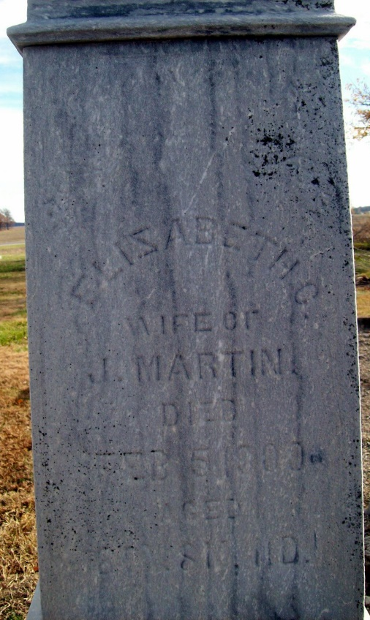
Photo by Jackie Sanders

Elizabeth Cresap Deffenbaugh from tree Nolan
Birth May 1828 Maryland, USA
Marriage 27 Jan 1846 Allen, Indiana, USA
Residence 1900 Adams, Indiana, USA
Death 5 Feb 1909 Allen, Indiana, USA
Father John Deffenbaugh (1794-1863)
Mother Ellen Cresap Martin (1794-1870)
Spouse Josephus Martin (1803-1892)

