Hannah (Pine) Huffman
January 20, 1814 – June 13, 1900

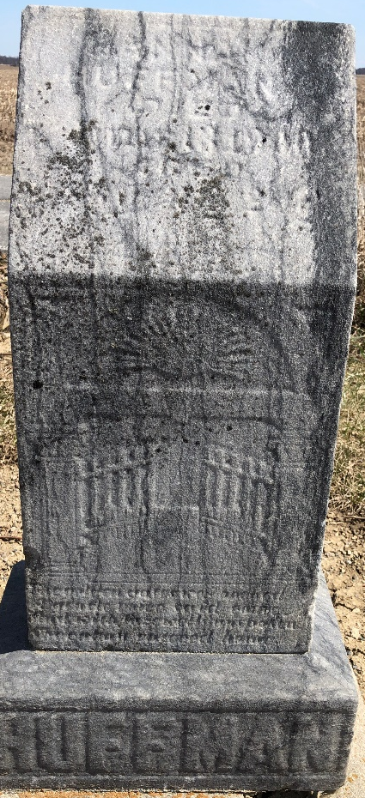
Photo by Jackie Sanders

Mrs. Hannah Huffman, daughter of Mr. and Mrs. John Pine, was born in Pennsylvania, January 20, 1814, and departed this life at the home of her son, near Linn Grove, June 13, 1900. Aged 86 years, four months, and twenty-four days.
In childhood she removed with her parents to Ohio, where in 1832 she was united in marriage to David Huffman, after which they removed to Adams County, Indiana, in 1844.
To this union nine children were born, five sons and four daughters. The husband and three children preceeded her to the land of promise. Three sons, three daughters, forty-five grandchildren and sixty-five great-great grandchildren remain to mourn a loss which is her gain.
In early youth she united with the Primitive Baptist Church, to which she remained faithful until the end.
She was very patient during her long sickness of eight months of pain and suffering. She often spoke of her wish to meet death and to be taken into the rest which Heaven alone can give.
The funeral services were conducted from the Union Chapel M. E. Church, June 15, Rev. N. Peters, of Portland, officiating. Interment at Brown Cemetery.

Decatur Democrat, Adams County, Indiana
June 21, 1900
**
Hannah Huffman
in the Indiana, U.S., Death Certificates, 1899-2017
Name Hannah Huffman
[Hannah Pine]
Gender Female
Race White
Marital Status Widowed
Age 86 years, 4 months, 25 days
Birth Date abt 1814
Birth Place Pennsylvania
Death Date 13 Jun 1900
Death Place Hartford City, Adams, Indiana, USA
Death Registration Date 1899-1900
Father John Pine
Mother Elizabeth Bare
Informant John Huffman; Linn Grove, Indiana
Burial June 15, 1900; Brown Cemetery

