William F. Hall
July 19, 1863 – April 11, 1864

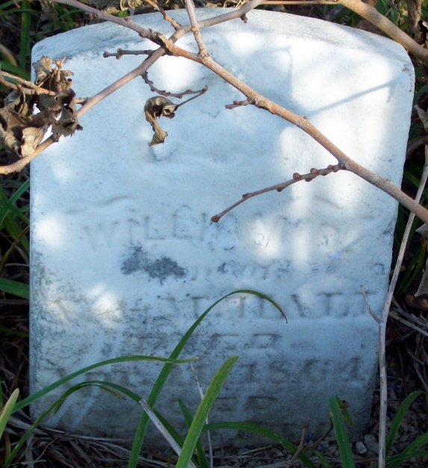
Photo by Jackie Sanders

William F Hall from tree Anderson Family Tree
Birth 19 Jul 1863 Adams, Indiana, USA
Death 11 Apr 1864 Adams, Indiana, USA
Father Nathan Hall (1834-1867)
Mother Melissa French (1838-1917)
7616 People 1 Record 2 Sources

