Margaret Hall
March 10, 1859 – March 16, 1861

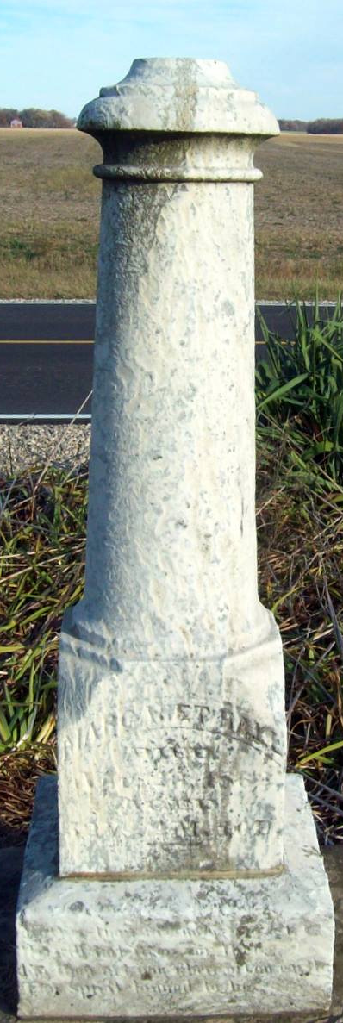
Photo by Jackie Sanders
Margaret Hall from tree Anderson Family Tree
Birth 10 Mar 1859 Adams, Indiana, USA
Death 16 Mar 1861 Adams, Indiana, USA
Father Nathan Hall (1834-1867)
Mother Melissa French (1838-1917)
7616 People 1 Record 2 Sources

