Eugene Elroy Hall
July 23, 1874 – July 5, 1875

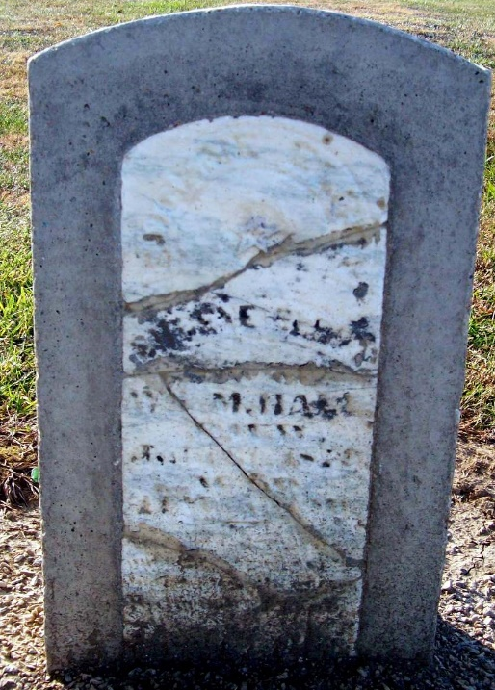
Photo by Jackie Sanders
Eugene Elroy Hall from tree Cassidy Family Tree
Birth 23 Jul 1874 Adams, Indiana, USA
Death 5 Jul 1875 Adams, Indiana, USA
Father Nathan Hall (1834-1867)
Mother Melissa French (1838-1917)

