Alice Mary Hall
January 28, 1884 – January 29, 1890

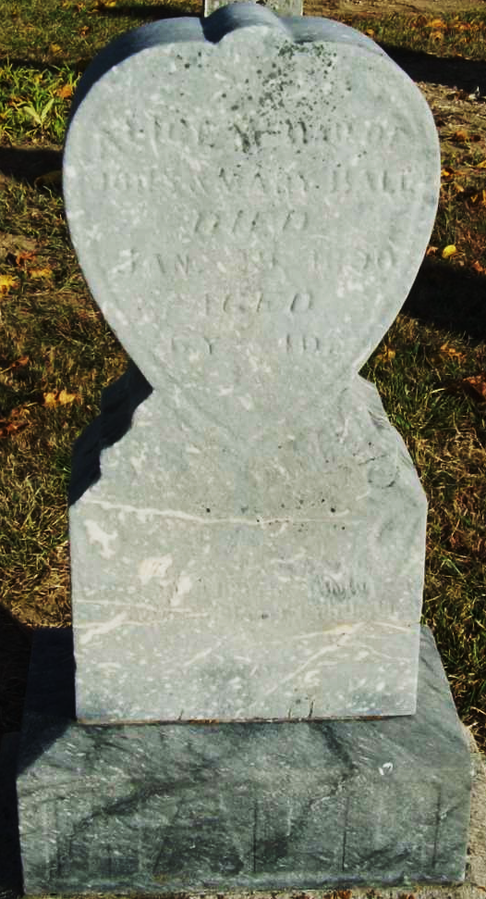
Photo by Jackie Sanders
Alice Mary Hall from tree Anderson Family Tree
Birth 28 Jan 1884 Adams, Indiana, USA
Death 29 Jan 1890 Adams, Indiana, USA
Father John B Hall (1830-1907)
Mother Mary Ann Burgess (1841-1928)

