Mary Jane Glendining
November 30, 1844 – October 20, 1876

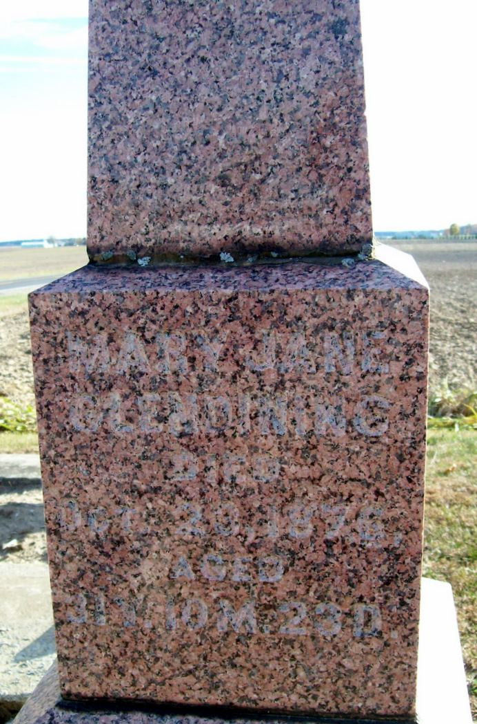
Photo by Jackie Sanders
Mary Jane Glendening from tree robert Jay Family Tree
Birth 30 Nov 1844
Death 20 Oct 1876 Adams, Indiana, USA
Father James Glendening (1810-1887)
Mother Catherine Watson (1814-1879)
3299 People 4 Records 4 Sources

