James Glendining
August 26, 1810 – September 22, 1887

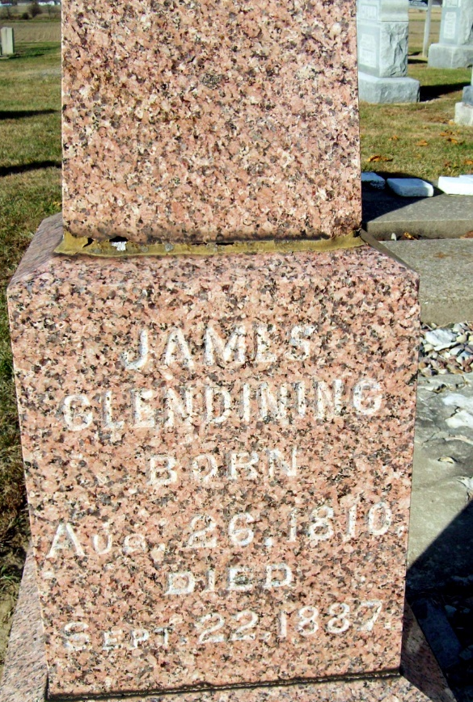
Photo by Jackie Sanders
James Glendening from tree Glendening Family
Birth 26 Aug 1810 Monzie, Perthshire, Scotland
Marriage 1835 England
Residence 1880 Adams, Indiana, USA
Death 22 Sep 1887 Adams, Indiana, USA
Father George Glendening (1776-1821)
Mother Margaret Paslow (1770-1883)
Spouse Catherine Watson (1814-1879)

