Catherine (Watson) Glendining
September 2, 1814 – February 27, 1879

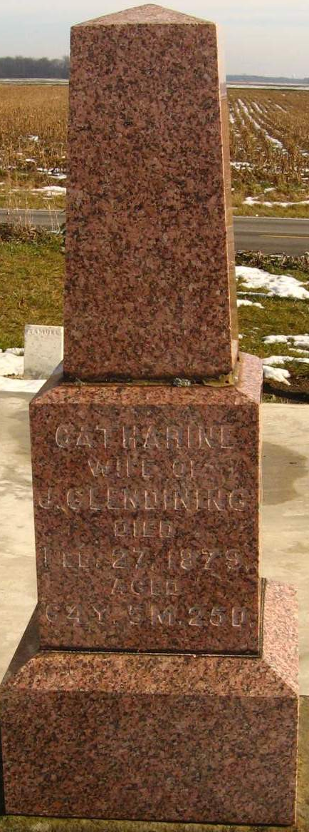
Photo by Tombstoner & Family
Catherine Watson from tree Scott Family Tree
Birth 2 Sep 1814 England
Marriage 1835 England
Residence 1870 Adams, Indiana, USA
Death 27 Feb 1879 Indiana, USA
Father John Watson (1786-1844)
Mother Sarah Westgarth (1783-1877)
Spouse James Glendening (1810-1887)

