Daniel Erastus Fields
November 24, 1875 – October 9, 1889

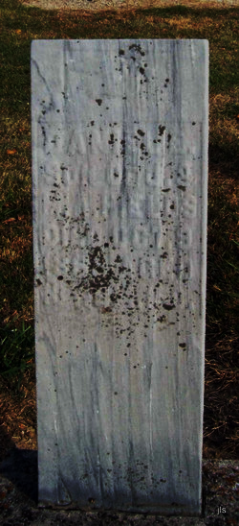
Photo by Jackie Sanders

Daniel Erastus Fields from tree Fields Family Tree-1
Birth 24 Nov 1875 Geneva, Adams, Indiana, USA
Residence 1880 Adams, Indiana, USA
Death 9 Oct 1889 Indiana, USA
Father Joel David Fields (1846-1942)
Mother Mary Ann Swaney (1847-1922)

