Andrew J. Fields
March 28, 1818 – January 17, 1909

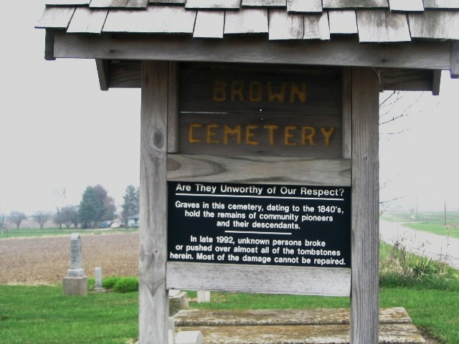
Photo by Barbara Baker Anderson

Andress Field
in the Indiana, U.S., Death Certificates, 1899-2017
Name Andrew Fields
Gender Male
Race White
Marital Status Widowed
Age 90 years, 9 months, 9 days
Birth Date 28 Mar 1818
Birth Place Tenn.
Death Date 17 Jan 1909
Death Place Geneva, Adams, Indiana, USA
Death Registration Date 1909
Father Martin Fields
Mother M?? Manor
Informant Mrs. Donald Sham??; Geneva, Indiana
Burial January 18, 1909; Brown Cemetery

