Alex Fields
July 2, 1804 – August 28, 1830

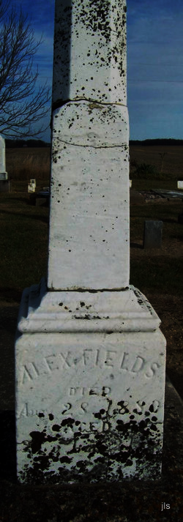
Photo by Jackie Sanders

No further information found at this time

