William Barnard
January 14, 1850 – February 20, 1872

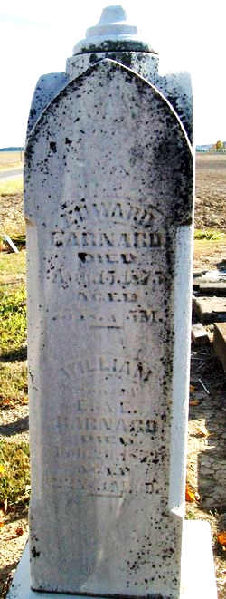
Photo by Jackie Sanders

William Barnard from tree Wolfe Family Tree
Birth 14 Jan 1850 Adams, Indiana, USA
Residence Aug 1870 Adams, Indiana, USA
Death 20 Feb 1872 Adams, Indiana, USA
Father Edward Barnard* (1800-1875)
Mother Eliza McDowell* (1822-1892)

