Rebecca J. Barnard
September 14, 1854 – November 1, 1856

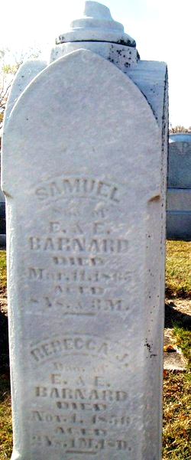
Photo by Jackie Sanders

Rebecca J Barnard in Possible Relatives tree
Father Edward S Barnard
Mother Elizabeth "Eliza" Berry
Birth 14 Sep 1854
Death 1 Nov 1856

