Alexander Kimble
March 12, 1844 - February 12, 1895

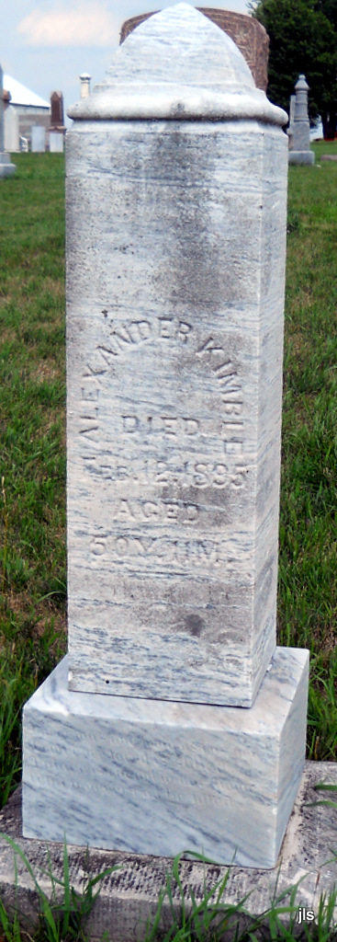
Photo by Jackie Sanders

No obit found at this time

