Charity Jurden (Shigly) Johnson
September 21, 1856 – December 6, 1939

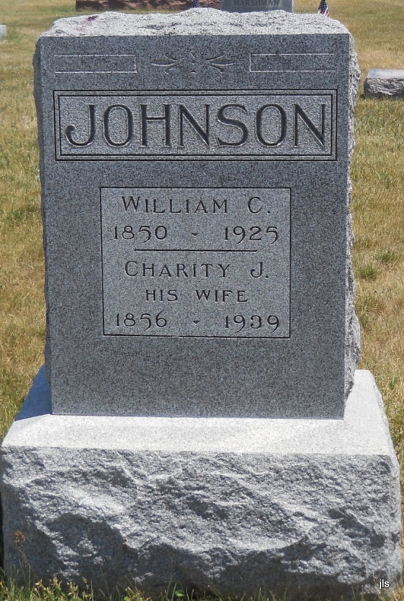
Photo by Jackie Sanders

Charity Johnson's Demise Is Sudden
Death Occurs at Home in Nottingham Township of Heart Attack
Mrs. Charity Shigley Johnson, 83, widow of William C. Johnson, died at 2:30 a.m. today at her home two miles east of Petroleum.
Her sudden death was caused by a heart attack. The decedent was born Sept. 21, 1856 to John S. and Mariah Reed Shigly. Mrs. Johnson's marriage took place in Nottingham Township in 1876 to W. C. Johnson, who died in 1925.
Surviving are the children, Hugh and Forrest Johnson, of Los Angeles; Mrs. Berle Mullin, of Hoopeston, Ill.; John Robert Johnson, of Bluffton; Ray Johnson, of Reiffsburg; Mrs. Lulu Bussell and Mrs. Clara Fosnaugh, both of Petroleum; Mrs. Jesse Lockwood, of Huntington, and Melvin Johnson, of Bluffton.
The body will be taken this evening from the Wells & Hardy funeral home in Geneva to the residence. Funeral arrangements have not been completed pending word from the sons in California.

Bluffton News-Banner, Wells County, IN; December 6, 1939, Page 1

