Dana E. James
October 10, 1949 – May 29, 2011

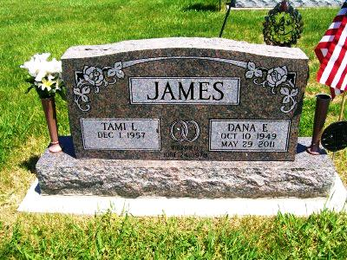
Photo by Scott Shoup

Dana E. James, 61, of Decatur, passed away on Sunday, May 29, 2011, at Lutheran Hospital in Fort Wayne. He was born on October 10, 1949, in Grant County, Indiana, to Lewis F. and Phyllis Ann (Heideman) James. He married Tami L. Brodbeck on June 24, 1978.
He is survived by his parents, Lewis and Phyllis James of Van Buren; his wife, Tami L. James of Decatur; four children, Marc (Naomi) James of Rapid City, South Dakota; Donita (Joe) O'Grady of Fort Wayne; William James of Decatur; and April (Dustin) Bollinger of Decatur; three brothers, David James of Fort Wayne, Randall (Rita) James of Van Buren, and Dennis (Cindy) James of Decatur; and seven grandchildren.
Dana worked at Fleetwood RV in Decatur for 35 years. He served his country during the Vietnam War in the United States Army from 1968-1973 and was a member of American Legion Post 43 in Decatur.
Visitation will be on Wednesday, June 1, 2011, from 2-4 and 5-8 p.m. at Haggard Sefton and Hirschy Funeral Home in Decatur. The funeral service will be held on Thursday, June 2, 2011, at 10 a.m., also at the funeral home. Burial will be in Alberson Cemetery at Geneva, with military graveside rites by American Legion Post 43's color guard.
Memorials may be made to the Strickler Cancer Institute at Adams Memorial Hospital in Decatur.

Haggard-Sefton & Hirschy Funeral Home online obit (accessed May 30, 2011)

